C:\Users\MyPC\Pictures\RAGE ID\ID RAGE7.tif

C:\Users\MyPC\Pictures\RAGE ID\ID RAGE7.tif

**Danao City, Cebu, Philippines**

**C E R T I F I C A T I O N**

AUGUST 26, 2025

This is to certify that **BAYLON G. CAPUTOLAN** is a regular member of **RADIO AMATEUR GROUP FOR EMERGENCY-7DC INC (RAGE -7DC)** base in Danao City, Cebu. He has attended with the group’s seminar and reviews for the amateur radio rules and regulation.

This certification is being issued for his application for the amateur radio examination.

Very Truly Yours,

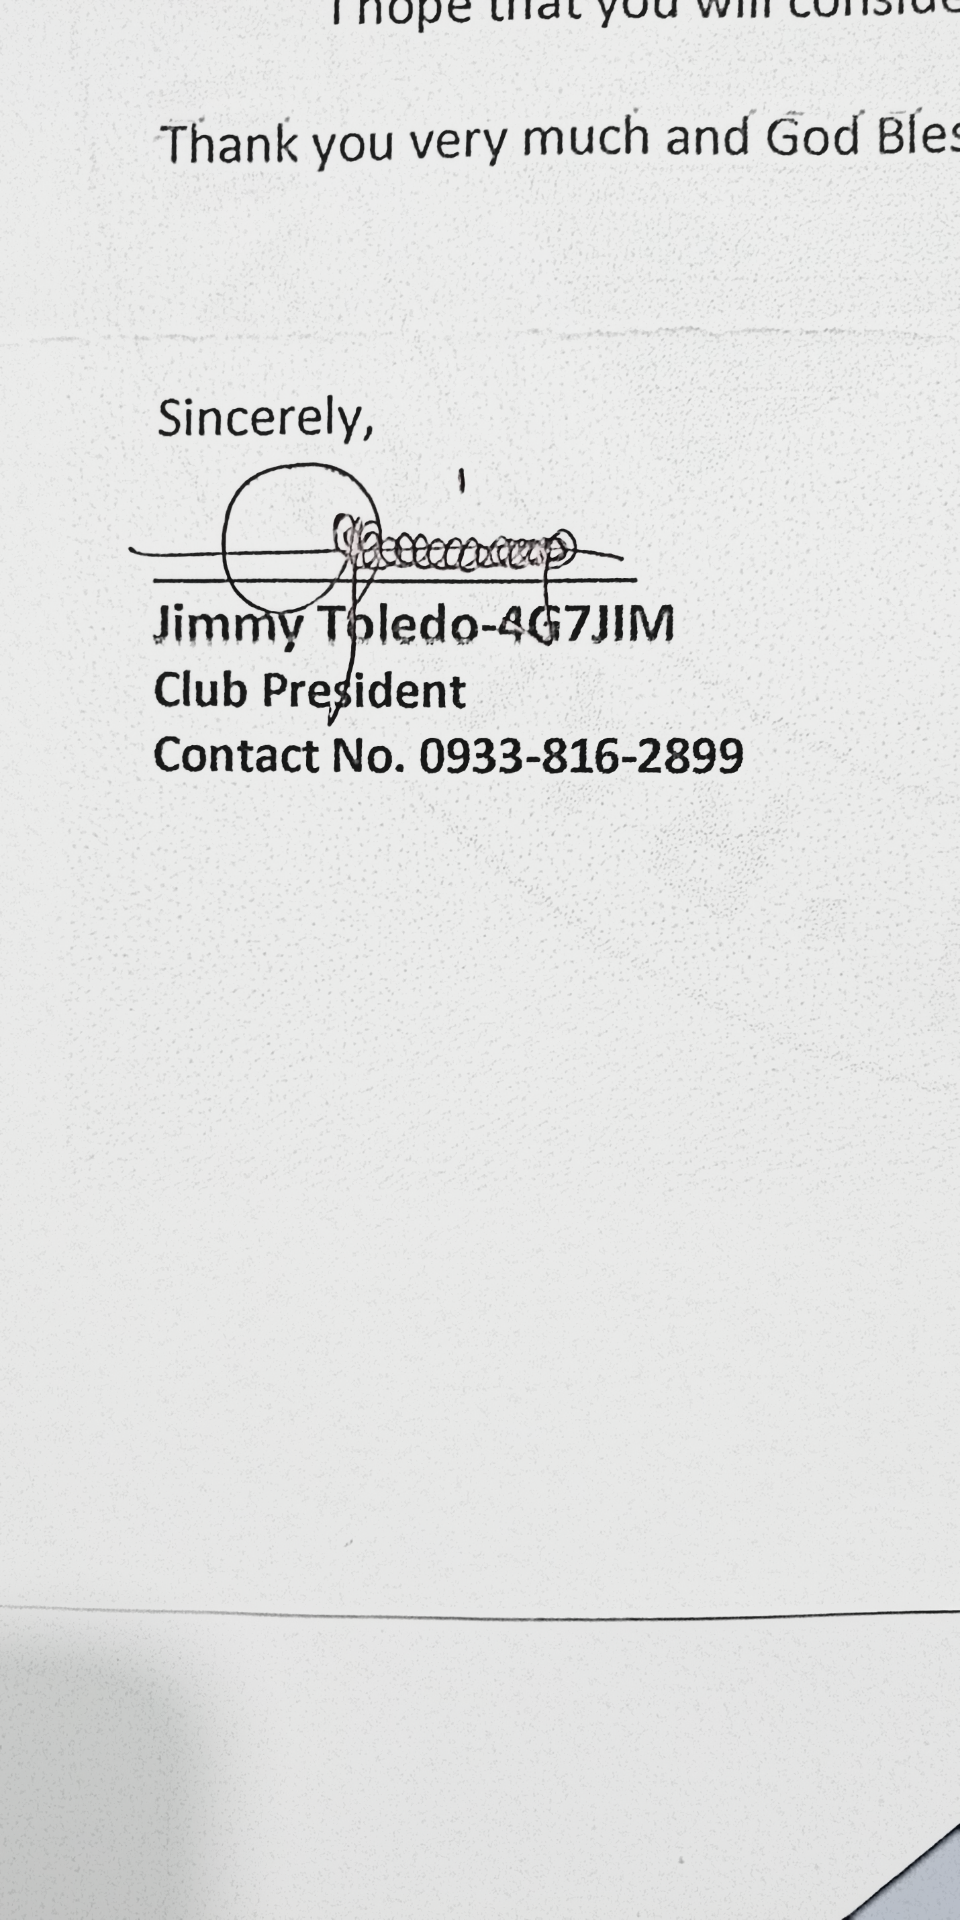

Control No. RAGE 7 DX-DAG-08-2025